Screenshot of $Env:PATH output.
Screenshot of $Env:MYVAR="HelloWorld" and verifying with $Env:MYVAR
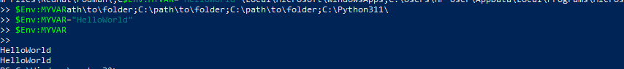
Screenshot of where.exe python or where.exe notepad showing PATH resolution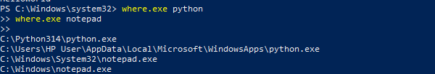
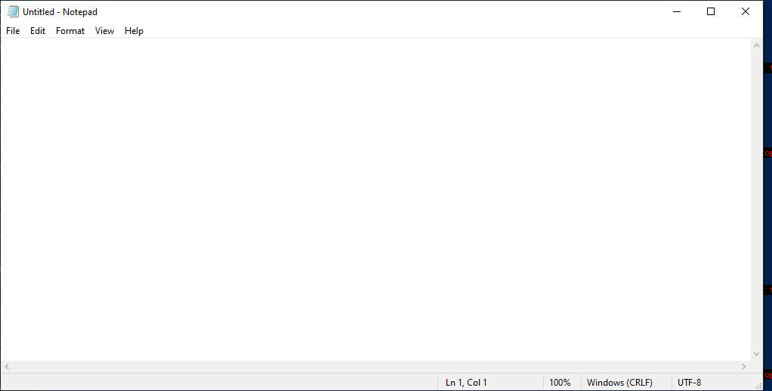
Screenshot of Environment Variables GUI (System Properties → Environment Variables) with custom entries.
